**Course Title: Functional English for Career Development**

Duration: 40 Hours

Target Audience: UG and PG students, job seekers, and professionals

Objective: To enhance English language proficiency for workplace communication and career advancement

**Module 1: Workplace Communication Basics (6 Hours)**

1. Introduction to Workplace English (1 Hour)

Importance of English in career development

Common workplace communication challenges

1. Basic Business Communication Skills (2 Hours)

Formal vs. informal communication

Email and letter writing basics

1. Workplace Vocabulary and Expressions (3 Hours)

Common phrases for meetings, emails, and networking

Business idioms and jargon

**Module 2: Resume Writing & Job Applications (6 Hours)**

1. Crafting a Professional Resume (2 Hours)

Types of resumes

Writing strong objective statements and skills sections

1. Cover Letters & Job Applications (2 Hours)

Structure and tone of cover letters

Writing effective job application emails

1. Handling Job Portals & Online Applications (2 Hours)

Creating LinkedIn profiles

Writing compelling summaries and job descriptions

**Module 3: Interview & Presentation Skills (8 Hours)**

1. Interview Preparation & Common Questions (3 Hours)

Introducing yourself professionally

Answering behavioral and technical questions

1. Mock Interviews & Feedback (2 Hours)

Role-playing exercises

Constructive feedback

1. Presentation Skills for Workplaces (3 Hours)

Structuring a presentation

Speaking confidently & using visual aids

**Module 4: Workplace Writing Skills (8 Hours)**

1. Email Writing & Professional Etiquette (3 Hours)

Writing concise and clear emails

Common email errors and how to avoid them

1. Report & Proposal Writing (3 Hours)

Structuring reports and proposals

Using formal tone and appropriate vocabulary

1. Minutes of Meetings & Business Correspondence (2 Hours)

Writing minutes effectively

Professional memos and notices

**Module 5: Soft Skills & Workplace Communication (6 Hours)**

1. Team Communication & Collaboration (3 Hours)

Handling workplace conflicts

Active listening and negotiation skills

1. Cross-cultural Communication & Workplace Diversity (3 Hours)

Understanding cultural differences

Communicating effectively in a global workplace

**Module 6: Advanced Career Development & AI in Job Search (6 Hours)**

1. Using AI for Career Growth (3 Hours)

AI tools for resume writing and job applications

Practicing interviews with AI-powered tools

1. Career Growth Strategies & Personal Branding (3 Hours)

Building a professional online presence

Networking strategies and continuous learning

Assessment & Certification

Mid-course assessment (20%) – Email writing and resume submission

Final assessment (40%) – Mock interview

**Lesson Plans**

**MODULE 1:**

**Basics of Work Place Communication (6 hours)**

1. Introduction to work place english and importance of English in career development (1 hour)
2. Challenges in work place communication and basic business communication. (2 hours)
3. Formal vs informal communication, basics in Email and letter writing workplace vocabulary and expression. (3 hours.)

Session 1: Introduction to Workplace English & Its Importance (1 Hour)

**Learning Objectives:**

Understand the role of English in professional settings.

Recognize the significance of English in career growth.

Teaching Methods:

Lecture & Discussion: Importance of English in global workplaces.

Activity: Think-Pair-Share – Students discuss how English has helped professionals in different fields.

Case Study: A success story of an employee who improved their career through English proficiency.

**Key Topics:**

Role of English in multinational and local workplaces.

How communication skills impact career growth.

Examples of successful professionals with strong English communication skills.

**Assessment:**

Short reflection: “How can improving my English skills help my career?” (Written response – 100 words).

**Session 2:**

Challenges in Workplace Communication & Basic Business Communication (2 Hours)

Learning Objectives:

Identify common workplace communication challenges.

Learn key business communication strategies.

Teaching Methods:

Brainstorming: Students list difficulties they face in workplace communication.

Lecture & Discussion: Explanation of common challenges (e.g., cultural differences, miscommunication, lack of confidence).

Role-play: Simulating workplace scenarios (e.g., handling misunderstandings, active listening).

Case Studies: Examples of workplace miscommunication and solutions.

Key Topics:

Common workplace communication challenges.

Strategies for overcoming communication barriers.

Active listening, clarity, and conciseness in business communication.

Assessment:

Group presentation: Identify a communication problem in the workplace and propose a solution.

Session 3: Formal vs. Informal Communication, Workplace Writing & Vocabulary (3 Hours)

Learning Objectives:

Differentiate between formal and informal communication.

Learn the basics of workplace emails and letters.

Expand workplace vocabulary and professional expressions.

Teaching Methods:

Lecture & Discussion: Characteristics of formal vs. informal communication (examples from real-world workplace interactions).

Group Activity: Students categorize phrases as formal or informal.

Email Writing Practice: Writing a professional email (e.g., requesting leave, responding to a client).

Letter Writing Basics: Structure of a business letter (e.g., complaint, appreciation, resignation letters).

Vocabulary Building: Common workplace expressions and phrases.

Key Topics:

Differences between formal and informal communication.

Email etiquette (subject lines, tone, structure).

Basics of business letter writing.

Workplace vocabulary and commonly used phrases.

Assessment:

Email writing task: Write a formal email to request a meeting with a manager.

Letter writing exercise: Draft a short business letter (e.g., an appreciation letter).

Workplace vocabulary quiz.

Expected Outcomes:

By the end of this module, students will:

Understand the role of English in workplace communication.

Identify and overcome communication barriers in professional settings.

Use formal and informal communication appropriately.

Write professional emails and letters effectively.

Use workplace vocabulary and expressions with confidence.

Would you like any modifications based on your students' needs?

Lesson Plan: Introducing Yourself and Others in a Professional Setting

Grade Level: Graduation Functional English

Duration: 2 hours

Learning Objective: Students will be able to effectively introduce themselves and others in a professional setting, demonstrating appropriate verbal and non-verbal communication skills.

Materials Needed:

Whiteboard and markers

Printed handouts with introduction phrases and templates

Role-play scenario cards

Timer

Projector (optional for multimedia presentations)

Notebooks and pens for students

Assessment rubrics for introductions

Standards:

Aligning to state standards for effective communication and professional development, focusing on verbal and non-verbal skills necessary for workplace interactions.

Lesson Overview: This lesson is designed to culminate in student proficiency in introducing themselves and others, essential for job interviews, networking, and professional environments.

Lesson Procedure:

Introduction (15 minutes)

Begin by engaging students with a brief discussion around experiences that require introductions, such as job interviews or networking events.

Ask questions like:

"What do you think is the purpose of introducing oneself?"

"How can a good introduction impact first impressions?"

Use responses to highlight the importance of crafting a professional introduction.

Presentation of Content (25 minutes)

Introduce the components of a professional introduction:

Start with a greeting.

State your name clearly.

Briefly mention your current role or educational status.

Add a personal touch (e.g., an interesting fact or what you do in professional settings).

Offer to introduce someone else or provide a transition to another relevant topic.

Present examples using the whiteboard:

"Hello, my name is [Your Name]. I am currently a [position/role] at [Company/School]. An interesting fact about me is [insert fact]."

Discuss the non-verbal components of a professional introduction—body language, eye contact, and a firm handshake.

Encourage students to think of how tone and clarity play a central role in professional settings.

Guided Practice: Introducing Yourself (20 minutes)

Hand out introduction templates and guide students to create their own introductions based on the components discussed.

Provide an example template:

"Hello, my name is _____ (name). I am a _____ (current role, e.g., student/employee) at _____ (company/school). An interesting fact about me is _____ (fun fact).”

Allow students 10 minutes to write their introductions, encouraging them to be creative but professional.

Pair students to practice their introductions with each other, providing supportive feedback focusing on clarity, engagement, and confidence.

Role-Playing Activity (40 minutes)

Split students into small groups. Provide each group with role-play scenario cards which may include:

Attending a job fair.

Networking at an industry conference.

Meeting potential mentors.

Each group will select a scenario and prepare a 5-minute role-play using the introductions they created earlier.

Encourage students to include different elements in their introductions based on the scenario context.

Students will present their role-plays to the class. Peers and the instructor should provide constructive feedback based on clarity, engagement, and professional demeanor.

Summative Assessment: Introduction Presentation (15 minutes)

Students will present their introductions individually in front of the class.

Each introduction should last about 1 minute.

As students present, utilize an assessment rubric to evaluate:

Clarity of speech

Appropriateness of content

Engagement with peers (eye contact, body language)

Provide immediate and specific feedback after each presentation.

Closure (5 minutes)

Recap the components of a professional introduction.

Highlight a few successful examples from the presentations to inspire students.

Encourage students to practice their introductions outside of class in real professional situations.

Reflection and Feedback:

After the lesson, ask students to reflect on their learning:

"What did you find challenging about introducing yourself?"

"How can you apply what you learned today in your future professional engagements?"

Collect reflections to gauge understanding and areas for improvement.

Assessment:

Use the rubric during presentations to track each student's understanding of effective introductions.

Review written templates for clarity and creativity as an additional measure of understanding.

Modifications:

For students with speech challenges, provide written or recorded introductions as an alternative.

Use pair work strategically to pair students with different skill levels, promoting peer learning.

Follow-Up:

Encourage students to practice their introductions in various environments throughout the week and report back on their experiences in the next class. Include a reflection component that addresses any challenges faced and areas for further improvement.

Formal Vs Informal Communication

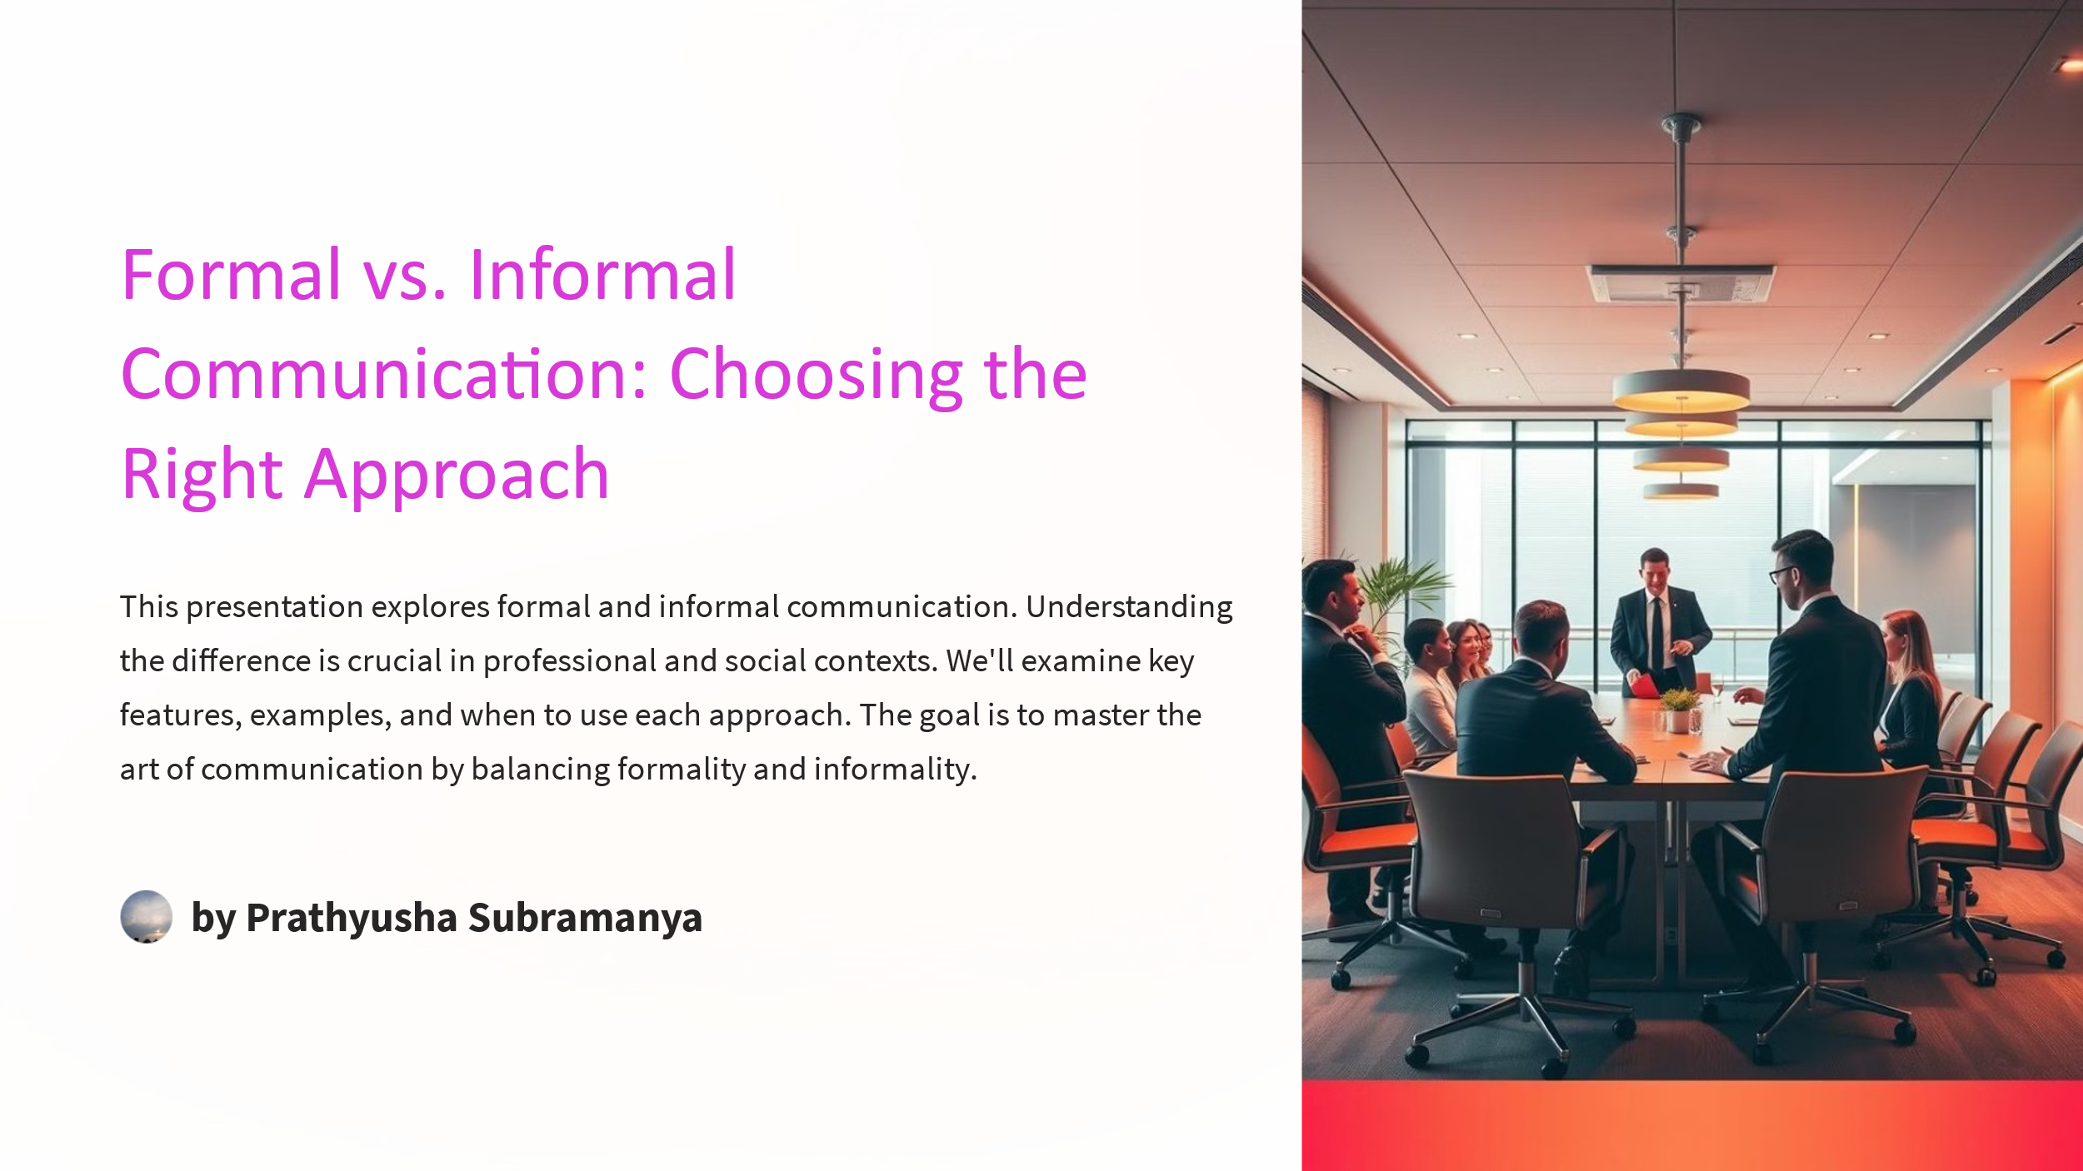

**Assessment**

1. In workplace communication, what is the key difference between formal and informal language?

Choices

A) Formal language uses complex sentence structures, while informal language uses simpler structures.

B) Formal language is appropriate for internal communications only, while informal language is for external communications.

C) Formal language adheres to established conventions and professional tone, while informal language is more relaxed and personal.

D) Formal language is used primarily in verbal communication, while informal language is preferred in written communication.

2. When crafting a resume, how does a skills section contribute to making a strong impression on potential employers?

Choices

A) It presents a narrative about your past achievements and career aspirations.

B) It showcases skills that directly align with the job requirements, demonstrating your suitability for the role.

C) It provides a comprehensive list of all skills acquired throughout your professional journey.

D) It details your hobbies and interests, giving employers insight into your personality.

3. During an interview, what is the primary goal of answering behavioral questions?

Choices

A) To provide a chronological account of your educational background and work experience.

B) To showcase your technical skills and expertise in the field.

C) To demonstrate how you have handled specific situations in the past, providing insight into your problem-solving abilities and character.

D) To impress the interviewer with your knowledge of the company's history and values.

4. What is the main purpose of adhering to professional etiquette in email writing?

Choices

A) To minimize the length of the email and save time for the recipient.

B) To convey respect, maintain a positive relationship, and ensure effective communication.

C) To ensure the email is visually appealing and formatted correctly.

D) To showcase your expertise and mastery of the English language.

5. How does active listening contribute to effective team communication and collaboration in the workplace?

Choices

A) It shows respect for others' perspectives, facilitates understanding, and promotes constructive dialogue.

B) It allows individuals to dominate conversations and assert their opinions.

C) It enables individuals to multitask during meetings and phone calls.

D) It encourages team members to interrupt each other to express their ideas.

6. In a global workplace, what is the significance of understanding cross-cultural communication?

Choices

A) It enables you to stereotype individuals based on their cultural background.

B) It helps you avoid misunderstandings, show respect, and build positive relationships with colleagues from diverse backgrounds.

C) It teaches you how to ignore cultural differences to streamline communication.

D) It allows you to impose your cultural values on others.

7. How can AI tools be used in job applications to enhance candidate success?

Choices

A) By replacing the need for personalized cover letters and networking.

B) By guaranteeing job placement based on algorithmic assessments.

C) By automating the entire application process without human intervention.

D) By providing suggestions for resume writing, identifying optimal keywords, and offering interview practice.

8. Why is building a professional online presence considered essential for career growth?

Choices

A) It ensures complete privacy and protection from online scrutiny.

B) It helps you eliminate face-to-face networking altogether.

C) It allows you to share personal opinions without consequences.

D) It enhances visibility, establishes credibility, and opens doors to new opportunities in the digital age.

9. How should you approach writing minutes of meetings to ensure they are effective?

Choices

A) Distribute the minutes only to attendees who request them.

B) Focus on summarizing key decisions, action items, and discussion points concisely and accurately.

C) Include personal opinions and interpretations of the discussions.

D) Capture every word spoken to provide a comprehensive transcript.

10. What is the most effective strategy for continuous learning and career development?

Choices

A) Ignoring feedback from colleagues and supervisors.

B) Seeking out new courses, attending workshops, and staying updated with industry trends.

C) Avoiding new challenges and sticking to familiar tasks.

D) Relying solely on past experiences and knowledge.

**Team**

Professor Bangla Bharathi GDC Sadashivapet

Associate Professor Suchitra Singh GDC Tara GDC Sangareddy

Rama Laxmi DL in English TTWRDC Sangareddy

T. S. Prathyusha DL in English TSWRDC Medak